Free Mammogram Clinic
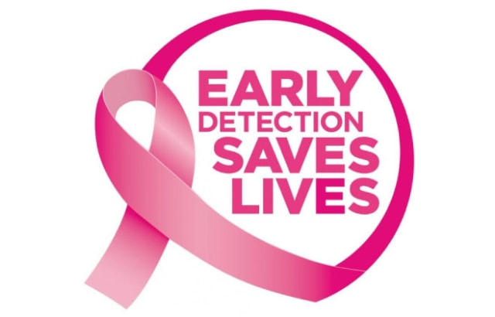
Thursday 1/26/23 8:30am-3:00pm
Event ER of Texas Texoma and Moncrief Cancer Institute
★ Free breast cancer screening for women without insurance and those who qualify
★ Mammograms for women 40 and older
★ Must be at least 1 year since last mammogram
Please call 800.405.7739 to schedule an appointment on Moncrief's Mobile Screening Clinic. The screening location is ER of Texas Texoma, 115 W. Travis St., Sherman, TX 75090.

